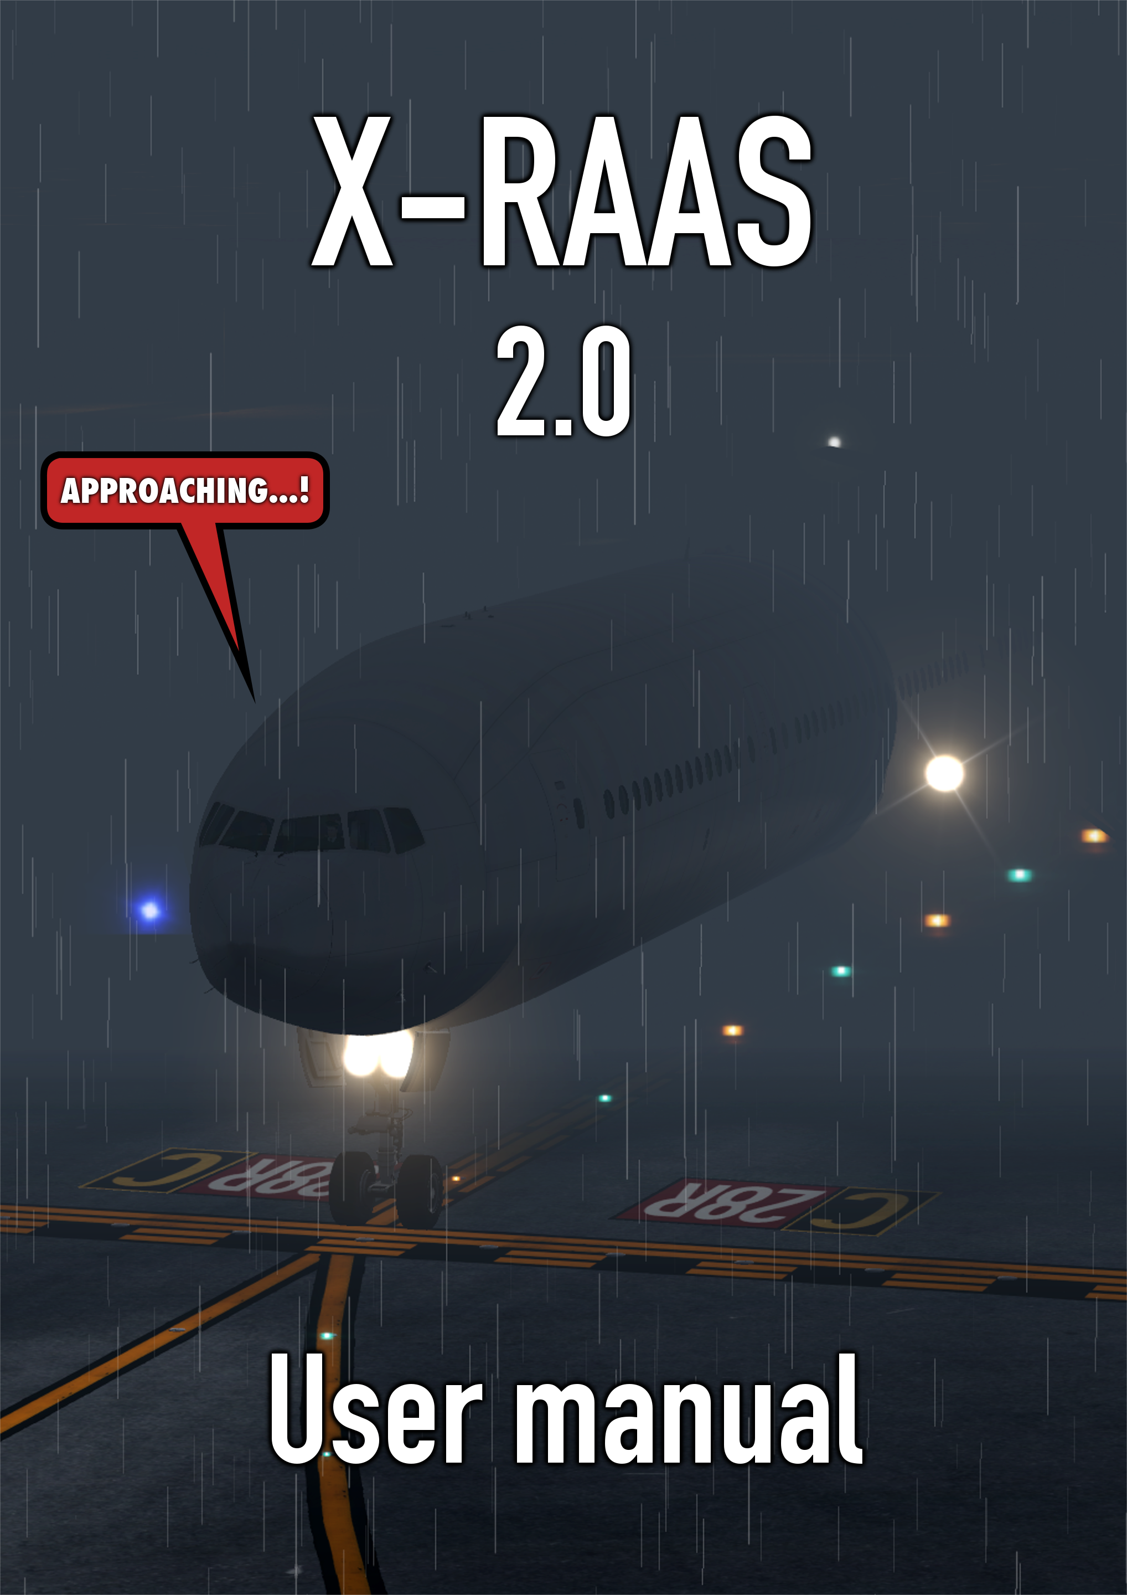

Table of Contents
1 Introduction 3
2 Installation 3
3 Activating X-RAAS in the aircraft 3
3.1 Annunciation mechanism and aircraft integration 3
3.1.1 Aural annunciations 3
3.1.2 Visual annunciations 4
4 Advisories 5
4.1 Approaching a runway on the ground 5
4.2 Lined up on runway for takeoff 6
4.2.1 Extended holding on a runway 6
4.3 Lined up on runway too short for takeoff 6
4.4 Short runway takeoff 7
4.5 Taxiway takeoff 7
4.6 Late rotation on takeoff 7
4.7 Rejected takeoff 8
4.8 Altimeter setting climbing through transition altitude 9
4.9 Altimeter setting descending through transition level 10
4.10 Approaching a runway to land 11
4.11 Late flap selection during approach to land 12
4.12 Steep descent late in the approach to land 13
4.13 Excessive airspeed on approach 14
4.14 Attempting to land on a parallel taxiway 15
4.15 Long landing 16
4.16 Landing rollout runway length remaining 17
4.17 Go-around 18
4.18 Runway exit via high-speed exit taxiways 19
5 Configuration 20
5.1 Graphical configuration 20
5.2 Text-based configuration 26
6 Electrical system integration 32
7 Compatibility notices 33
7.1 Feature compatibility matrix 33
8 About the X-RAAS project 34
8.1 Author 34
8.2 Acknowledgements 34
8.3 License 34

Introduction
X-RAAS implements a simulation of the Honeywell Runway Awareness and Advisory System (RAAS), which is itself a set of software extensions to the Enhanced Ground Proximity Warning System (EGPWS) computer. RAAS monitors the aircraft's GPS position and other sensor inputs to construct a picture of the aircraft's position relative to runways and several other threat conditions. When a potentially hazardous condition is detected, RAAS issues caution and warning aural annunciations and visual advisories. X-RAAS models most of these annunciations.

Installation
To install X-RAAS, simply extract the installation ZIP archive into the plugins folder. Once installed, X-RAAS will begin to function automatically. After installation, your X-Plane folder structure should look like this:
 <X-Plane 10 Folder>
Resources
plugins
X-RAAS2
After installation, the first time you start up X-Plane, X-RAAS will scan all of your airport sceneries and extract runway information to build its airport data cache. This can take up to 10 seconds or more (depending on how much scenery you have). Once the cache is built, X-RAAS will use the cache and startup will be much faster. The reason for this cache is to make sure that X-RAAS's runway information matches your scenery as closely as possible, so you don't get spurious runway alerts. Once started up, X-RAAS should not impose any significant additional load on your simulator.
X-RAAS checks for updates to airport scenery or the AIRAC database in the simulator during startup. If scenery is added or removed, or the AIRAC cycle is changed, X-RAAS will automatically recreate its airport data cache.
NOTE
Updates to existing scenery might not be detected, as X-RAAS doesn't attempt to detect file modifications. If you have significantly updated existing scenery and would like to force X-RAAS to refresh its airport data cache, simply use the menu entry “Plugins”→“X-RAAS”→“Recreate data cache”.

Activating X-RAAS in the aircraft
X-RAAS automatically begins functioning as soon as electrical power is applied to the aircraft's primary avionics systems. Normally, RAAS is only used by airliners with a sophisticated EGPWS. RAAS advisories and performance monitoring can be a poor fit for small general aviation aircraft or aircraft with performance significantly different from airliners. To avoid this, by default X-RAAS checks if the current aircraft isn't a helicopter and also two additional parameters about the currently loaded aircraft prior to starting up:
- The aircraft must have at least two or more engines.
- The aircraft's Maximum Take Off Weight (MTOW) must be at least 5,700 kg or more.
If the aircraft is a helicopter or the value of the above mentioned parameters is less than the limits, X-RAAS startup is inhibited. All of this is configurable in the X-RAAS configuration file, so it is possible to re-enable X-RAAS for any aircraft in X-Plane, provided sufficient electrical power is available. See section 5 for details on how to fine tune X-RAAS's behavior.
Please note that certain aircraft models are either wholly incompatible with X-RAAS, or have certain features restricted. Refer to section 7 for a list of aircraft with known compatibility issues.

Annunciation mechanism and aircraft integration

Aural annunciations
Aural annunciations are made normally through the aircraft's loudspeaker system. The following details of aural annunciations can be adjusted (refer to section 5 for details on configuring X-RAAS):
- Audio volume.
- Voice gender.
- Style of runway number pronunciation (should single-digit runways have a '0' prepended or not).
- Units of measure (feet or meters).
- Whether to append units of measure to the initial callout.
If the current simulator view is external, annunciations are suppressed.

Visual annunciations
If visual annunciations are supported, they are performed in one of two ways:
- Overlaid in large type on the aircraft's navigation or multifunction displays in the 3D cockpit (see illustrations 1 and 2).
- Using a semi-translucent on-screen overlay near the top center of the screen.
Display of visual annunciations in the 3D cockpit model requires 3rd party aircraft integration. If an aircraft does not provide this integration, X-RAAS will by default fall back to display visual annunciations using the on-screen overlay. If the current simulator view is external, annunciations are suppressed.
Please note that not all real aircraft feature visual annunciations in their avionics. In these cases, X-RAAS will disable all visual annunciations. Refer to section 7.1 for a list of aircraft which support visual annunciations and by what mechanism. Aircraft developers are encouraged to refer to section Error: Reference source not found for details and sample code for integrating visual annunciation into their simulated avionics.
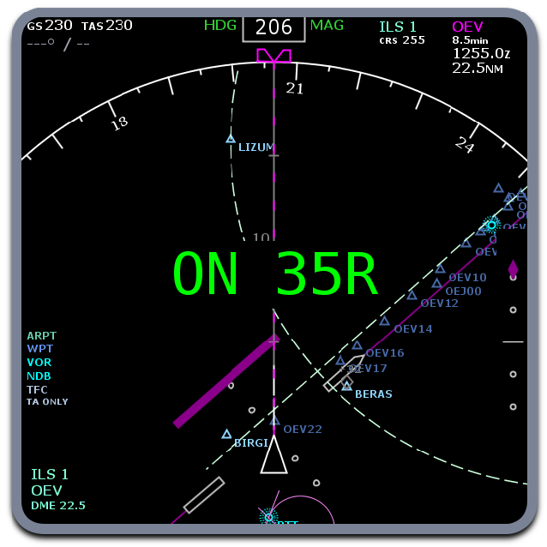Illustration 1: Example routine visual annunciation
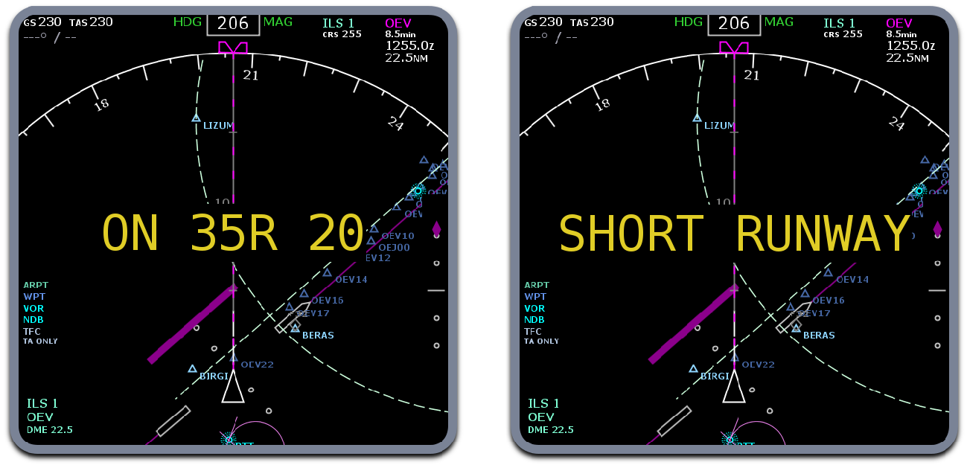
Illustration 2: Example non-routine and caution annunciations

Advisories
This section lists all the various normal and caution advisories X-RAAS can issue for various potential hazards. It is organized by phase of flight, starting with initially approaching a runway on the ground for takeoff and progressing towards a landing and runway exit.

Approaching a runway on the ground
X-RAAS constructs a virtual bounding box around each runway which extends laterally approximately 1.5x the runway width from the runway centerline and 2,000 feet longitudinally from each runway threshold. X-RAAS will issue an advisory when the aircraft's nose is approximately 1 second from penetrating this bounding box (calculated based on ground speed). The advisory names the runway end closest to the aircraft.
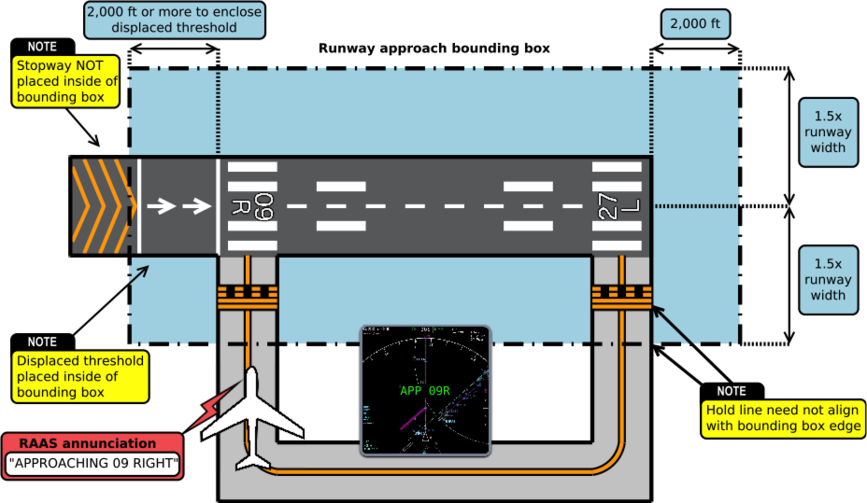Illustration 3: Approaching a runway on the ground
The aural advisory is accompanied by a routine green visual advisory on the ND:
APP XX
Where 'XX' is the runway identifier. The advisory is inhibited when ground speed exceeds 40 knots (to prevent activation on takeoff through intersecting runways). Please also note that the annunciation does not guarantee the ability to stop before entering the runway.

Lined up on runway for takeoff
This annunciation is made initially on lining up on a runway (aircraft heading is within approximately 25 degrees of runway heading). The aural advisory is accompanied by a routine green visual advisory:
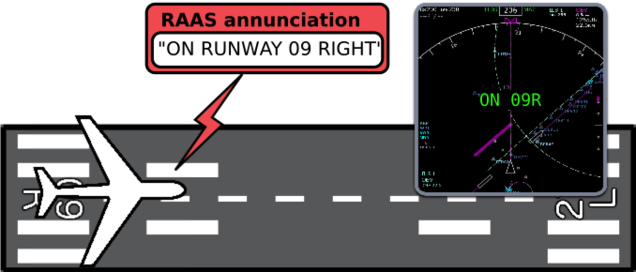Illustration 4: Lined up on runway for takeoff
ON XX
Where 'XX' is the runway identifier. This annunciation may be supplemented by an annunciation of “FLAPS, FLAPS” if the appropriate takeoff flap configuration has not yet been selected at the time of line up. The takeoff flaps advisory is inhibited if the GPWS flaps override mode is active. If the 'FLAPS, FLAPS' annunciation is to be issued, an amber 'FLAPS' visual caution advisory will be issued instead of the green 'ON XX' advisory:
FLAPS

Extended holding on a runway
If the aircraft holds in position on a runway for an extended period of time, the on-runway annunciation repeats as a non-routine advisory at configurable intervals. Holding in position is defined as the aircraft being aligned with a runway while its ground speed doesn't exceed 4 knots. The aural annunciation is repeated twice per interval (e.g. “ON RUNWAY 09 RIGHT, ON RUNWAY 09 RIGHT”) and displays an amber “ON XX” visual advisory. The default intervals are defined as follows:
- Delay until the initial annunciation: 60 seconds
- Delay until repeat annunciation: 120 seconds
- Maximum number of repetitions: 3
After the advisory has been repeated for the maximum number of repetitions, further advisories are inhibited until the aircraft lines up with another runway. Refer to section 5 for the interval configuration parameters RAAS_on_rwy_warn_initial, RAAS_on_rwy_warn_repeat and RAAS_on_rwy_warn_max_n.

Lined up on runway too short for takeoff
If the runway length remaining for takeoff is below an operator-defined minimum for a safe takeoff, the “on runway” annunciation is supplemented by a runway distance available readout (rounded down to the nearest 100 feet or meters). The aural advisory is accompanied by a non-routine amber visual advisory on the ND:
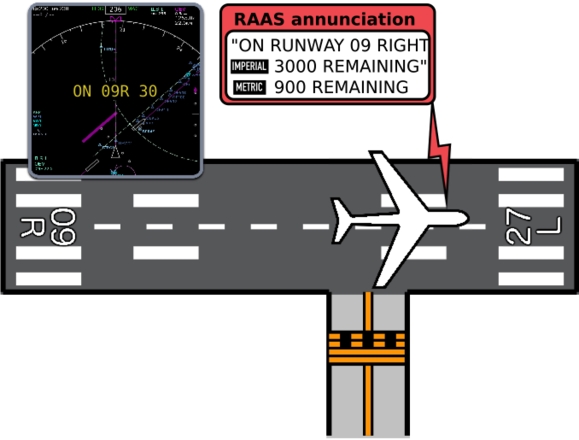Illustration 5: Lined up on runway too short for takeoff
ON XX YY
Where 'XX' is the runway identifier and 'YY' is the runway length available in hundreds of feet or meters.

Short runway takeoff
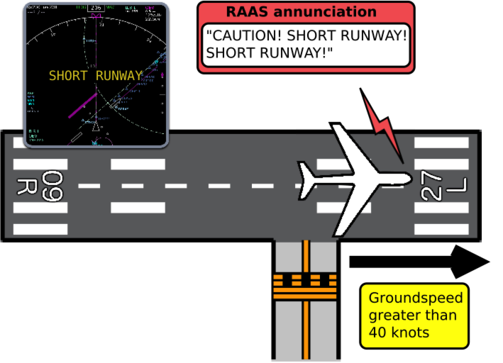Illustration 6: Short runway takeoff
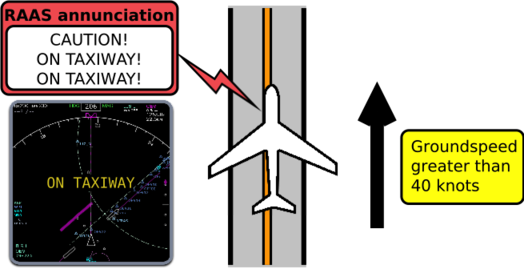Illustration 7: Taxiway takeoff
If takeoff is attempted on a runway with runway length remaining below an operator defined minimum, once ground speed exceeds 40 knots, a warning annunciation is generated: “CAUTION! SHORT RUNWAY! SHORT RUNWAY!” The aural advisory is accompanied by a caution amber visual advisory on the ND:
SHORT RUNWAY

Taxiway takeoff
This annunciation warns of attempting takeoff on a taxiway, typically after missing a turn onto the intended departure runway.
The conditions for triggering this annunciation are:
- Aircraft is NOT on a runway
- Ground speed exceeds 40 knots
The aural advisory is accompanied by a caution amber visual advisory on the ND:
ON TAXIWAY

Late rotation on takeoff
If the aircraft is on a runway and accelerates past 40 knots ground speed, X-RAAS switches into takeoff mode. Normally most annunciations are inhibited during this mode, however, if the runway length remaining drops below an operator-defined value and rotation has not yet been initiated, X-RAAS will start to issue runway length remaining annunciations to notify the crew of the rapidly approaching runway end and the need to initiate rotation as soon as possible. No visual advisories are generated.
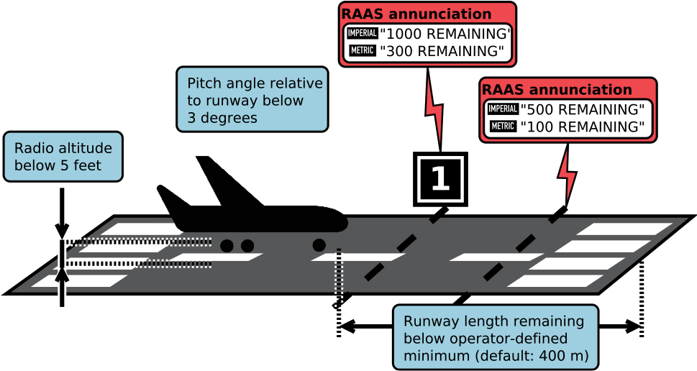Illustration 8: Late rotation on takeoff

Rejected takeoff
In takeoff mode (on runway and ground speed greater than 40 knots), X-RAAS closely monitors the aircraft's ground speed. If the aircraft decelerates 5 knots below the maximum ground speed attained during the takeoff roll, X-RAAS assumes that the takeoff is being rejected. During a rejected takeoff, if runway length remaining decreases below 9000 feet or 2700 meters, X-RAAS will start to issue runway length remaining annunciations. No visual advisories are generated.
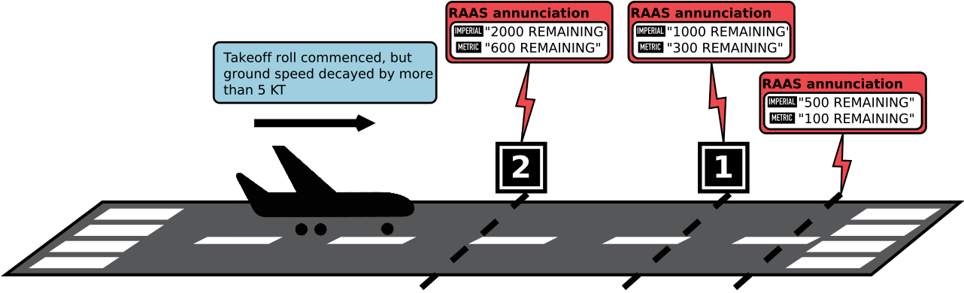Illustration 9: Rejected takeoff

Altimeter setting climbing through transition altitude
X-RAAS determines the transition altitude based on database information for the closest airport to the aircraft. If the aircraft climbs through the transition altitude, X-RAAS monitors the barometric altimeter subscale setting. If by 30 seconds after transitioning the subscale is not set to QNE (1013.25 hPa or 29.92 in.Hg), the following advisory is issued: “ALTIMETER SETTING”. This is to prevent incorrect altitude readings in cruise, which increases the possibility of traffic collisions. The aural advisory is accompanied by a caution amber visual advisory on the ND:
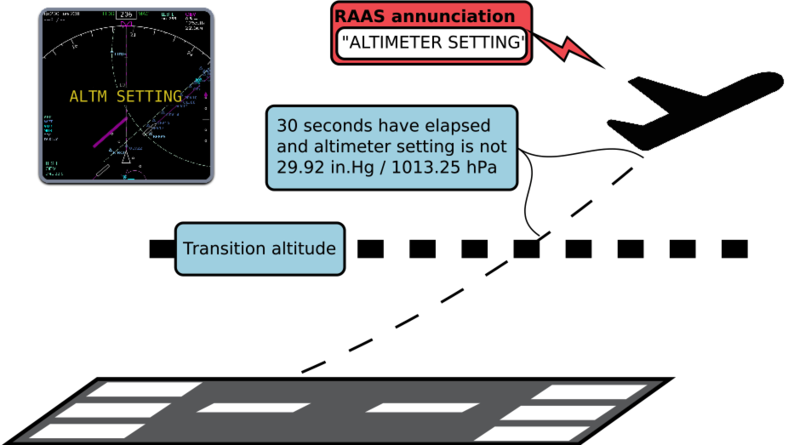Illustration 10: Altimeter setting climbing through transition altitude
ALTM SETTING
Please note that this advisory might not be available if transition altitude is not published in the navigation database. Flight crews must remain fully alert to crossing the transition altitude and reliance on the altimeter setting RAAS annunciation as part of standard operations is prohibited.

Altimeter setting descending through transition level
This is the reverse advisory to the altimeter setting advisory during climb and is intended to assist in preventing CFIT (Controlled Flight Into Terrain). X-RAAS determines the transition level based on the navigational database entries of the airport closest to the aircraft. If a fixed transition level is not published, X-RAAS calculates the lowest possible transition level based on barometric pressure readings, GPS calculated elevation AMSL and a published transition altitude, such that the calculated transition level is equal in true elevation AMSL to the transition altitude. Please note that this fallback mechanism might not be as accurate as using the ATC-assigned transition level, so reliance on this annunciation to determine the correct transition level is prohibited.
Once the aircraft descends through the transition level, X-RAAS monitors the barometric altimeter reading and GPS-calculated altitude:
- If QNH altimetry is enabled, the GPS-determined elevation AMSL is compared to the barometric altimeter reading. If the values differ by more than a pre-determined threshold after more than 30 seconds has elapsed since crossing the transition level, an “ALTIMETER SETTING” annunciation is generated.
- If QFE altimetry is enabled, X-RAAS compares GPS-determined elevation above the nearest aerodrome with the barometric altimeter reading to make sure that they are within a pre-determined threshold.
The default altimetry mode is QNH. The 30 second timeout for the barometric altimeter setting check can be preempted and initiated early if the aircraft descends below 1,500 feet above field elevation of the nearest airport.
The aural advisory is accompanied by a caution amber visual advisory on the ND:
ALTM SETTING
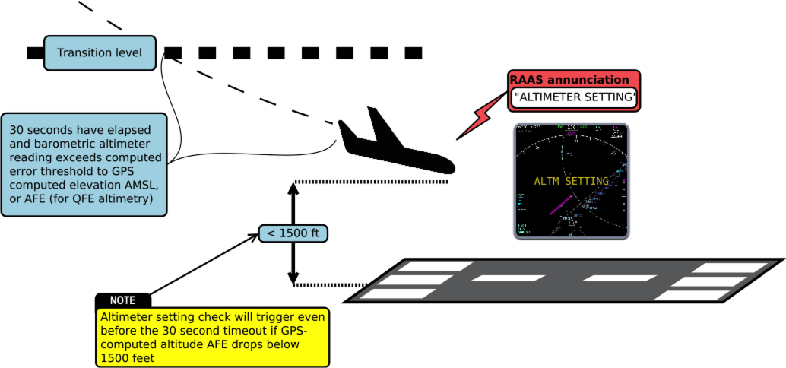Illustration 11: Altimeter setting descending through transition level

Approaching a runway to land
To facilitate proper runway alignment, X-RAAS issues a runway approach annunciation also when approaching a runway from the air with the intention to land. The following conditions need to be met for this annunciation:
- Within approximately 3 nm of a runway.
- Track is aligned with the runway and heading is within 25 degrees of runway heading.
- In landing configuration.
- Descending through between 700 feet and 320 feet above runway threshold elevation.
The aural advisory is accompanied by a routine green visual advisory on the ND:
APP XX
Where 'XX' is the runway identifier. If the runway length is below an operator-defined minimum, the annunciation is supplemented by an additional callout of the length available for landing, rounded down to the nearest 100 feet or 100 meters. In this case, the following non-routine amber visual advisory displays on the ND instead:
APP XX YY
Where 'XX' is the runway identifier and 'YY' is the runway length available in hundreds of feet or meters. If the aircraft remains on approach, and descends below 400 feet, but is above 320 feet, an additional annunciation is made: “CAUTION. SHORT RUNWAY! SHORT RUNWAY!” This annunciation is accompanied by a caution amber visual advisory:
SHORT RUNWAY
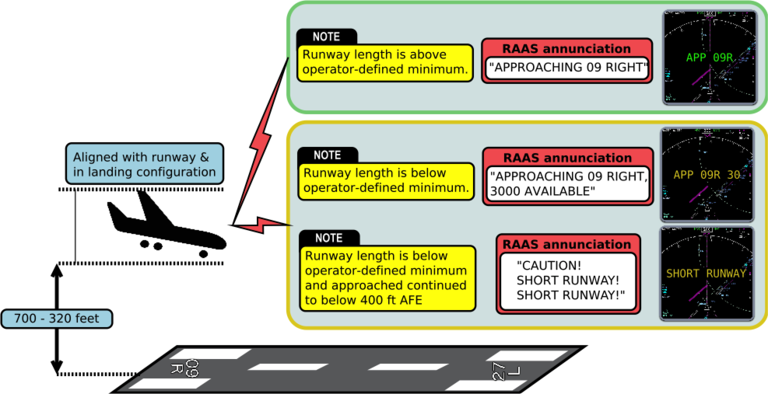Illustration 12: Approaching a runway to land

Late flap selection during approach to land
X-RAAS also monitors the flaps configuration during an approach to land and issues “FLAPS! FLAPS!” advisories in case flaps are not in the proper setting for landing at certain periods during the approach, based on height above runway threshold:
- 950 feet to 600 feet, annunciation: “FLAPS (pause) FLAPS” and a caution FLAPS annunciation on the ND.
- 600 feet to 450 feet, annunciation: “FLAPS! FLAPS!” and a caution FLAPS annunciation on the ND.
- 450 feet to 300 feet, annunciation: “UNSTABLE! UNSTABLE!” and a caution UNSTABLE annunciation on the ND.
- This annunciation is inhibited if:
  - the aircraft descends below 300 feet above threshold elevation, or
  - the GPWS flaps override mode (or terrain override mode if the aircraft isn't equipped with a separate flaps override mode) is active, or
  - gear is not down or the rate of climb exceeds 300 feet per minute.
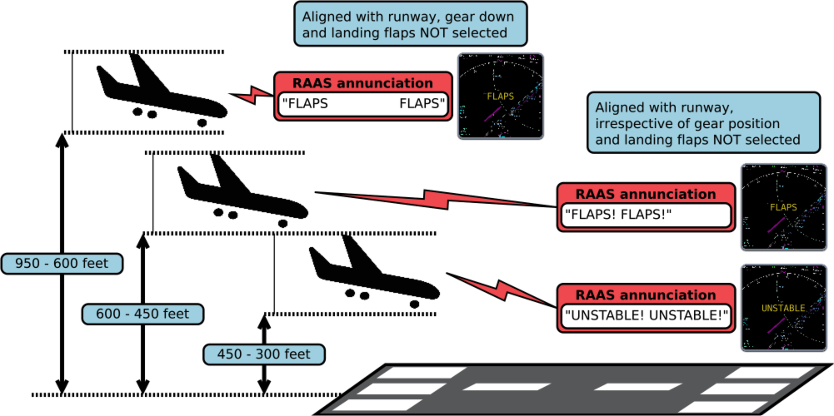Illustration 13: Late flap selection during approach to land

Steep descent late in the approach to land
To protect against steep descents late in the landing approach and “dive bombing it” at the last moment, X-RAAS calculates the aircraft glide path angle and compares it with the optimal glide path angle stored in the database for the runway. If the actual glide path angle exceeds a limiting angle, X-RAAS issues caution advisories, depending on height above runway threshold:
- 950 feet to 600 feet: aural: “TOO HIGH (pause) TOO HIGH” visual: TOO HIGH
- 600 feet to 450 feet: aural: “TOO HIGH! TOO HIGH!” visual: TOO HIGH
- 450 feet to 300 feet: aural: “UNSTABLE! UNSTABLE!” visual: UNSTABLE
Annunciation is inhibited if:
- the aircraft descends below 300 feet above threshold elevation, or
- the GPWS terrain override mode is active, or
- the rate of climb exceeds 300 feet per minute.
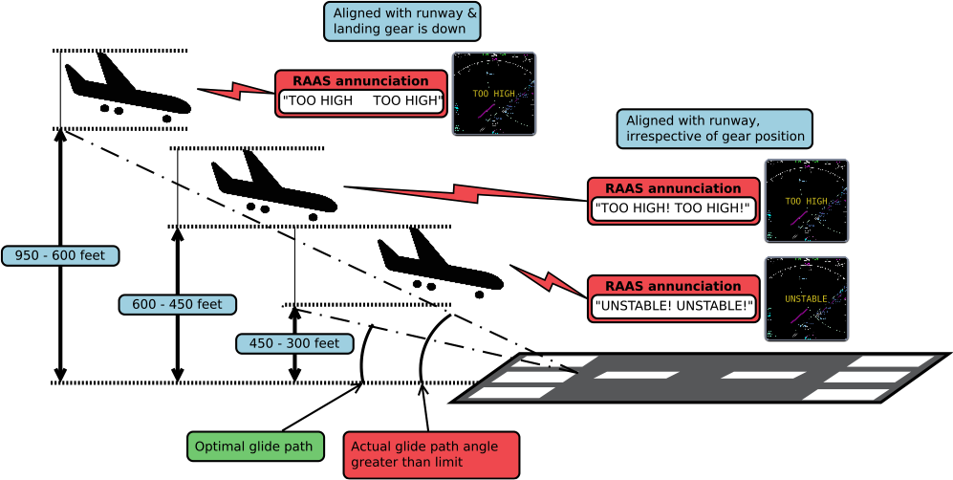Illustration 14: Steep descent late in the approach to land
The algorithm for calculating the limiting glide path angle is based on the aircraft's distance from the runway threshold. The distance determines a multiplier applied to the optimal angle. For example, if the multiplier is 2 and the optimal glide path angle is 3°, then the limiting angle is 6° for that particular point on the approach. Refer to the table below for details on the actual multiplier values used.
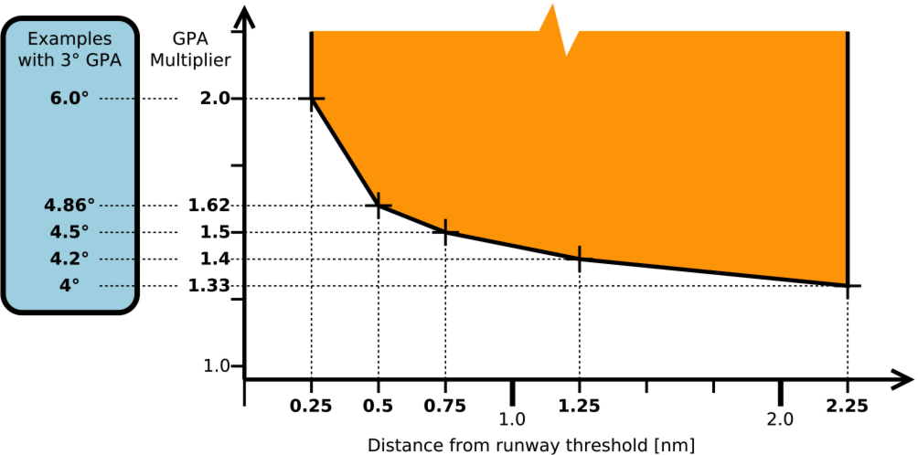

Excessive airspeed on approach
This check monitors airspeed during an approach and compares it with the landing speed set in the FMS. If the indicated airspeed becomes excessive while passing through pre-determined height gates above threshold elevation, X-RAAS will issue the following annunciations:
- 950 feet to 600 feet: aural: “TOO FAST (pause) TOO FAST” visual: TOO FAST
- 600 feet to 450 feet: aural: “TOO FAST! TOO FAST!” visual: TOO FAST
- 450 feet to 300 feet: aural: “UNSTABLE! UNSTABLE!” visual: UNSTABLE
Annunciation is inhibited if:
- the aircraft descends below 300 feet above threshold elevation, or
- the GPWS terrain or flaps override mode is active, or
- the rate of climb exceeds 300 feet per minute.
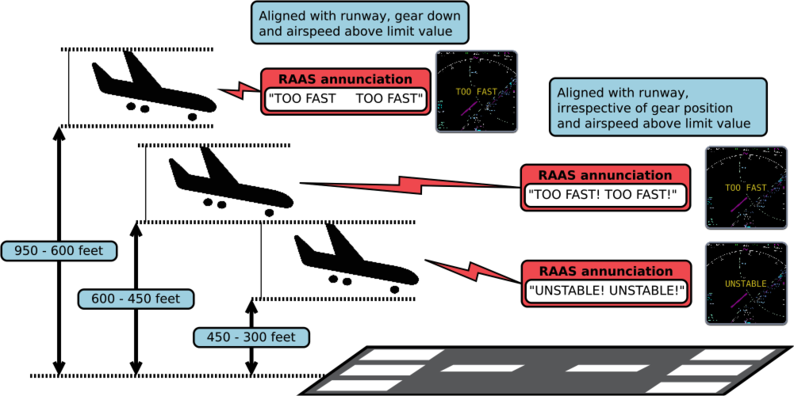Illustration 15: Excessive airspeed on approach
The amount of speed margin allowed above the landing speed depends on the height above the threshold and whether the landing speed includes wind and gust factors (V_{APP} – common on Airbus) or not (V_{REF} – common on Boeing):
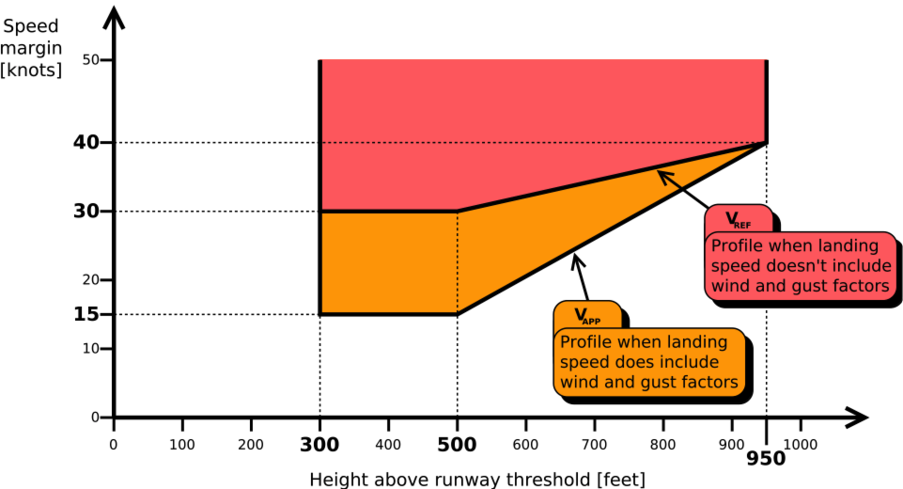
Please note that excessive approach speed monitoring requires aircraft-specific integration. Refer to section 7.1 for a list of aircraft which support this feature.

Attempting to land on a parallel taxiway
Many airports feature runways with close parallel taxiways. Under certain weather conditions, these can look very similar to each other during final approach and lead to confusion as to which is the runway and which is a taxiway. This increases the risk of an aircraft attempting to land on a taxiway, with obvious potential for a collision as a result.
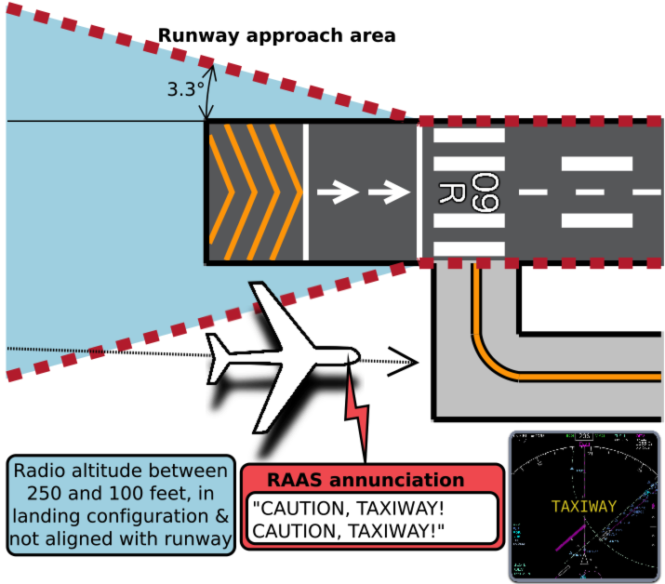Illustration 16: Attempting to land on a parallel taxiway
To help in preventing this hazard, X-RAAS closely monitors an aircraft's position during the final stages of approach. If X-RAAS detects the following conditions, it will issue a warning advisory:
- Radio altitude is less than 250 feet, but above 100 feet.
- Aircraft is in landing configuration (gear is down and flaps in the landing position).
- Aircraft is not in the runway approach area or is not aligned with the runway (aircraft heading within 20 degrees of runway heading).
The advisory is inhibited below 100 feet radio altitude or if the GPWS terrain override mode is active. The aural advisory is accompanied by a caution amber visual advisory on the ND:
TAXIWAY

Long landing
This annunciation protects against excessive floating on landing or an incorrectly executed too high or too fast approach, resulting in touch down very far down the runway and potentially insufficient runway length available for rollout. Conditions for this annunciation are:
- The aircraft is above the runway.
- Radio altitude indicates less than 100 feet, but more than 5 feet.
- Aircraft is past ¼ of the runway length or 2,000 feet from the approach end (whichever is shorter) or remaining runway length is less than an operator-defined minimum.
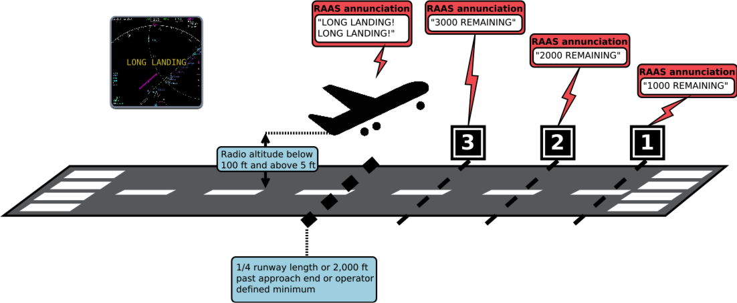Illustration 17: Long landing
X-RAAS will initially annunciate “LONG LANDING!” twice and the remaining runway length if it is less than 9,000 feet (2,700 meters) or an operator-defined maximum. Afterwards, X-RAAS will continue to annunciate runway length remaining every 1,000 feet (300 meters), unless the aircraft lands and decelerates below 40 knots ground speed, or performs a go-around (refer to section 4.17 for conditions monitored during a go-around). The aural advisory is accompanied by a caution amber visual advisory on the ND:
LONG LANDING

Landing rollout runway length remaining
During landing rollout, X-RAAS closely monitors aircraft position, ground speed and deceleration. If the aircraft approaches to within approximately 4,000 feet or 1,200 meters (configurable as an operator-defined value⁹), its ground speed is above 40 knots and the current rate of deceleration is insufficient to come to a complete stop prior to the end of the runway, X-RAAS will start issuing runway distance remaining annunciations in 1,000 foot or 300 meter increments. Thus the annunciation of runway length remaining during a normal landing indicates that additional braking might be required to bring the aircraft to a safe stop. The runway distance remaining annunciations are based on the position the aircraft's nosewheel will attain in approximately 1 second with an added approximate 200 foot or 60 meter buffer. Therefore a “3000 (feet) remaining” annunciation can be sounded between 3,000 to 3,200 feet remaining. The last 1,000 feet or 300 meters of runway length remaining feature two additional annunciations:
- The last 500 feet or 100 meters. Inhibited if ground speed is below 40 knots.
- The last 100 feet or 30 meters. This annunciation is sounded irrespective of ground speed as long as the aircraft remains aligned with the runway to warn the pilot of the need to perform an immediate stop or turn to avoid running off the end of the runway.
The runway length remaining is calculated based on the position of the threshold of the opposite runway. If the opposite runway features a displaced threshold, this displacement length is counted towards the runway length remaining, i.e. the displaced threshold portion of a runway is considered to be suitable for landing rollout. If the opposite runway features a stopway (a “blastpad”), this is NOT counted towards the runway length remaining. No visual advisories are generated.
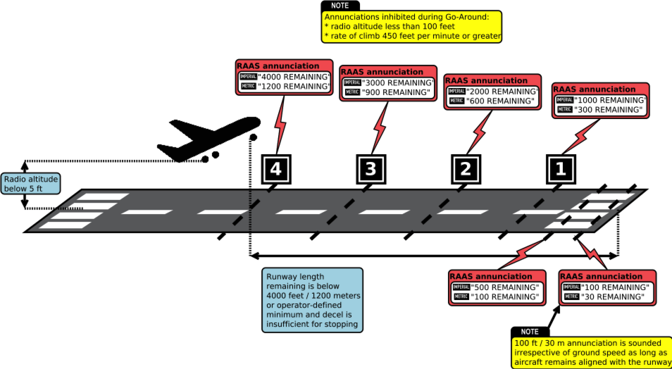Illustration 18: Landing rollout runway length remaining
Due to how X-RAAS is implemented, landing rollout annunciations are only guaranteed to sound if the aircraft is flying through each distance “gate” below a maximum ground speed:
Distance [feet] | Distance [meters] | Maximum ground speed [knots]
9,000 – 1,000 | 2,700 – 300 | 250
500 | 100 | 125
100 | 30 | 60

Go-around
During Go-around, runway length remaining annunciations are inhibited as soon as the aircraft climbs through 5 feet radio altitude and the following two conditions are met:
- radio altitude is below 100 feet
- rate of climb is 300 feet per minute or greater
If the rate of climb decays to below 300 feet per minute, runway length remaining annunciations are continued. If the aircraft climbs through 100 feet radio altitude, runway length remaining annunciations are not resumed, even if the aircraft resumes level flight.

Runway exit via high-speed exit taxiways
To support efficient high-traffic-density operations, landing traffic needs to be able to exit the runway environment after landing in an expeditious manner. To this end, many airports feature “high-speed exit” taxiways. These taxiways, rather than connecting to the runway at right angles, connect at relatively shallow angles, allowing landing traffic to maintain higher speed when turning off the runway. To support high-speed rollouts onto these kinds of taxiways, X-RAAS monitors groundspeed and aircraft position relative to the runway after landing. If the aircraft exceeds a limiting ground speed, this annunciation will be generated: “CAUTION! ON TAXIWAY! ON TAXIWAY!” and ON TAXIWAY on the ND.
- As long as the aircraft remains on a runway, no limiting ground speed is imposed.
- If the aircraft leaves the runway, but remains within the runway approach bounding box (as described in section 4.1), the limiting ground speed is 60 knots.
- If the aircraft leaves both the runway and the runway approach bounding box, the limiting ground speed is 40 knots.
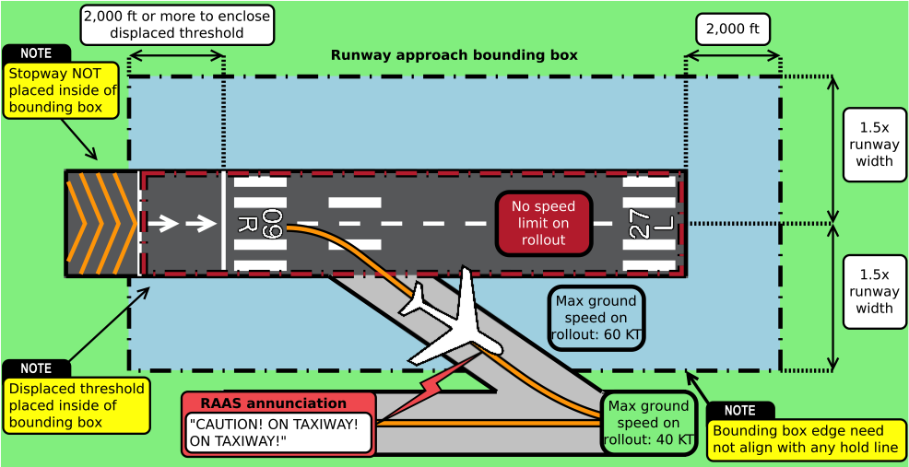Illustration 19: Runway exit via high-speed exit taxiways

Configuration
Just like the real system, X-RAAS can be extensively customized to suit the particular operational requirements of an aircraft or airline. For this purpose, X-RAAS contains both a graphical and textual configuration interface. Both interfaces have equivalent capability. The graphical configuration system simply generates a text configuration that is then stored on disk and read by X-RAAS during startup.

Graphical configuration
To invoke the graphical configuration interface, choose “Plugins”→”X-RAAS”→”X-RAAS configuration...” from the simulator's main menu menu. This will bring up the main configuration window:
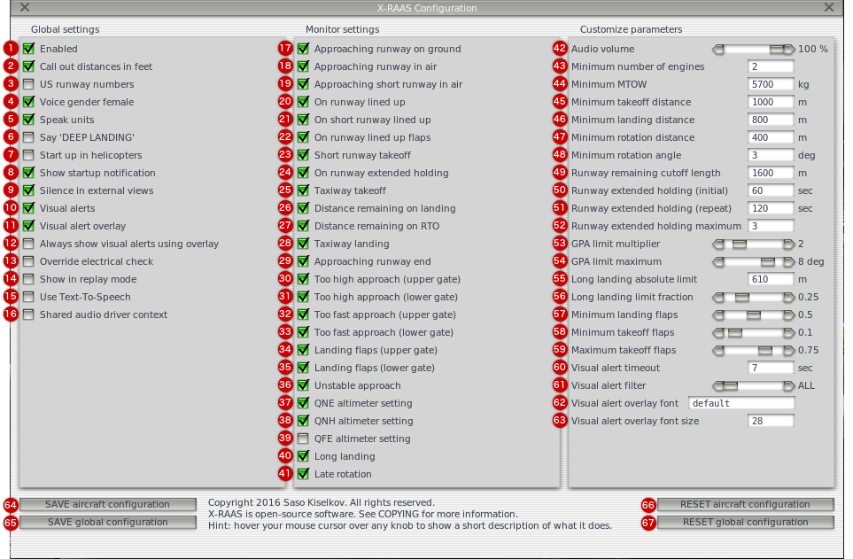
When open, the window will reflect the state of the current configuration of X-RAAS. You can make changes to the configuration and save it, or reset it to a default state. The following table explains what every control does:
# | Description | Default value | Equivalent textual configuration parameter
1 | The master ON/OFF switch.  ON: X-RAAS starts up if the current aircraft is compatible.  OFF: X-RAAS startup is completely inhibited. | ON | enabled
2 | Switches the unit of measure for distances used.  ON: use feet as the unit of measure in annunciations.  OFF: use meters as the unit of measure in annunciations.  This setting doesn't affect the units used in the configuration interface. The configuration interface always requires lengths and distances to be specified in meters. | ON | use_imperial
3 | X-RAAS has the option of pronouncing single-digit runways with or without prepending a leading '0'. Prepending '0' is ICAO-standard nomenclature, whereas not prepending '0' is used in FAA-governed territories.  ON: pronounce single-digit runway numbers without a leading '0' (e.g. '1L').  OFF: pronounce single-digit runway numbers with a leading '0' (e.g. '01L'). | OFF | us_runway_numbers
4 | Sets the aural annunciation voice gender.  ON: the voice of aural annunciations is female.  OFF: the voice of aural annunciations is male. | ON | voice_female
5 | During runway distance remaining or available annunciations, selects whether the units of measure used in the annunciation are appended to the initial annunciation (subsequent annunciations omit the units).  ON: append the units of measure used to initial distance annunciations.  OFF: don't append the units of measure used to distance annunciations.. | ON | speak_units
6 | If a late touchdown on landing is detected, this setting controls what nomenclature is used to annunciate this fact:  ON: annunciate late touchdown as 'DEEP LANDING'.  OFF: annunciate late touchdown as 'LONG LANDING'.  This setting does not control whether the long landing monitor is enabled. Refer to section 4.15 for more information. | OFF | say_deep_landing
7 | Controls whether X-RAAS startup is allowed if the current aircraft is detected to be a helicopter.  ON: permit startup if the current aircraft is a helicopter.  OFF: inhibit startup if the current aircraft is a helicopter.  This setting doesn't affect other compatibility checks, such as the minimum number of engines allowed or the minimum MTOW limit. Refer to section 3 for more information. | OFF | allow_helos
8 | On startup, X-RAAS displays a message at the bottom of the screen for 4 seconds to indicate that it is operating correctly and what units of measure are used for distance callouts, e.g:  - “Runway Awareness OK, Feet.”  - “Runway Awareness OK, Meters.”  ON: display of the startup message is enabled.  OFF: display of the startup message is inhibited.  This setting doesn't control startup of X-RAAS itself. | ON | startup_notify
9 | ON: while the simulator view is external, audible playback and display of visual overlay annunciations is inhibited.  OFF: while the simulator view is external, audible playback and display of visual overlay annunciations is permitted. | ON | disable_ext_view
10 | Controls whether the issuing of visual annunciations is enabled, irrespective of whether on the fallback screen overlay or on the aircraft's ND.  ON: permit issuing visual alerts on the ND or the screen overlay.  OFF: inhibit issuing visual alerts on the ND and the screen overlay.  Refer to section 3.1.2 for more information. | ON | nd_alerts_enabled
11 | Controls whether visual annunciations are allowed to be displayed using the fallback screen overlay.  ON: permit display of visual alerts using the screen overlay.  OFF: inhibit display of visual alerts using the on-screen overlay.  This doesn't inhibit the issuing of visual alerts, only their display on the overlay. If the aircraft model provides display of visual alerts in the virtual cockpit, those will be displayed even if this setting is set to OFF. Refer to section 3.1.2 for more information. | ON | nd_alert_overlay_enabled
12 | On aircraft which provide visual alert integration into the visual cockpit, X-RAAS will attempt to avoid showing the fallback screen overlay so as not to disturb the pilot by duplicate messages out of the virtual instrument frame. This setting allows you to override this behavior and force the display of the screen overlay.  ON: permit display of visual alerts using the fallback on-screen overlay.  OFF: inhibit display of visual alerts using the on-screen overlay.  Refer to section 3.1.2 for more information. | OFF | nd_alert_overlay_force
13 | Some aircraft models do not properly set the required datarefs for X-RAAS to detect electrical power being applied to the aircraft's avionics systems, resulting in X-RAAS being inoperable.  ON: permit startup even if insufficient power is being applied to the aircraft's electrical buses.  OFF: inhibit startup unless sufficient power is being applied to the aircraft's electrical buses. | OFF | override_electrical
14 | During replays, aircraft position can behave in strange and non-predictable ways, which can cause X-RAAS to give spurious annunciations.  ON: permit X-RAAS operation even if the simulator is currently in replay mode.  OFF: inhibit X-RAAS operation if the simulator is currently in replay mode. | OFF | override_replay
15 | In case you encounter compatibility issues with audio playback from X-RAAS and any other remedy is unavailable, you can force X-RAAS to play aural annunciations using the host operating system's text-to-speech function.  ON: use the host operating system's text-to-speech function.  OFF: use X-RAAS's own audio playback.  NOTE: this feature is not available on Linux. | OFF | use_tts
16 | When generating audio, X-RAAS can either use a dedicated OpenAL audio context, or a context shared with the rest of X-Plane. Certain audio drivers on Windows are known not to properly support multiple OpenAL contexts. If you encounter audio playback issues in that case, try to switch X-RAAS to use a shared audio context.  ON: X-RAAS should use an OpenAL audio driver context shared with the rest of X-Plane.  OFF: X-RAAS should use its own dedicated OpenAL audio driver context.  NOTE: operating using a shared context can result in compatibility issues with certain 3rd party plugins and aircraft. | OFF | openal_shared
17 | ON: the approaching runway on ground monitor is enabled.  OFF: the approaching runway on-ground monitor is disabled.  Refer to section 4.1 for more information. | ON | apch_rwy_on_gnd_mon
18 | ON: the approaching runway in air monitor is enabled.  OFF: the approaching runway in air monitor is disabled.  Refer to section 4.10 for more information. | ON | apch_rwy_in_air_mon
19 | ON: the approaching short runway in air monitor is enabled.  OFF: the approaching short runway in air monitor is disabled.  Refer to section 4.10 for more information. | ON | apch_rwy_in_air_short_mon
20 | ON: the on-runway lineup monitor is enabled.  OFF: the on-runway lineup monitor is disabled.  Refer to section 4.2 for more information. | ON | on_rwy_lineup_mon
21 | ON: the on-runway (short runway) lineup monitor is enabled.  OFF: the on-runway (short runway) lineup monitor is disabled.  Refer to section 4.3 for more information. | ON | on_rwy_lineup_short_mon
22 | ON: the on-runway lineup late flap selection monitor is enabled.  OFF: the on-runway lineup late flap selection monitor is disabled.  Refer to section 4.1 for more information. | ON | on_rwy_lineup_flaps_mon
23 | ON: the short runway takeoff monitor is enabled.  OFF: the short runway takeoff monitor is disabled.  Refer to section 4.4 for more information. | ON | on_rwy_tkoff_short_mon
24 | ON: the on-runway extended holding monitor is enabled.  OFF: the on-runway extended holding monitor is disabled.  Refer to section 4.2.1 for more information. | ON | on_rwy_hold_mon
25 | ON: the taxiway takeoff monitor is enabled.  OFF: the taxiway takeoff monitor is disabled.  Refer to section 4.5 for more information. | ON | twy_tkoff_mon
26 | ON: distance remaining callouts on landing are enabled.  OFF: distance remaining callouts on landing are disabled.  Refer to section 4.16 for more information. | ON | dist_rmng_land_mon
27 | ON: distance remaining callouts on rejected takeoff are enabled.  OFF: distance remaining callouts on rejected takeoff are disabled.  Refer to section 4.7 for more information. | ON | dist_rmng_rto_mon
28 | ON: the taxiway landing monitor is enabled.  OFF: the taxiway landing monitor is disabled.  Refer to section 4.14 for more information. | ON | twy_land_mon
29 | ON: the runway ending distance remaining callout is enabled.  OFF: the runway ending distance remaining callout is disabled. | ON | rwy_end_mon
30 | ON: the 'TOO HIGH' approach monitor upper gate (950-600 ft AFE) is enabled.  OFF: the 'TOO HIGH' approach monitor upper gate (950-600 ft AFE) is disabled.  Refer to section 4.12 for more information. | ON | apch_too_high_upper_mon
31 | ON: the 'TOO HIGH' approach monitor lower gate (600-450 ft AFE) is enabled.  OFF: the 'TOO HIGH' approach monitor lower gate (600-450 ft AFE) is disabled.  Refer to section 4.12 for more information. | ON | apch_too_high_lower_mon
32 | ON: the 'TOO FAST' approach monitor upper gate (950-600 ft AFE) is enabled.  OFF: the 'TOO FAST' approach monitor upper gate (950-600 ft AFE) is disabled.  Refer to section 4.13 for more information. | ON | apch_too_fast_upper_mon
33 | ON: the 'TOO FAST' approach monitor lower gate (600-450 ft AFE) is enabled.  OFF: the 'TOO FAST' approach monitor lower gate (600-450 ft AFE) is disabled.  Refer to section 4.13 for more information. | ON | apch_too_fast_lower_mon
34 | ON: the late flap selection approach monitor upper gate (950-600 ft AFE) is enabled.  OFF: the late flap selection approach monitor upper gate (950-600 ft AFE) is disabled.  Refer to section 4.11 for more information. | ON | apch_flaps_upper_mon
35 | ON: the late flap selection approach monitor lower gate is enabled.  OFF: the late flap selection approach monitor lower gate is disabled.  Refer to section 4.11 for more information. | ON | apch_flaps_lower_mon
36 | The conditions checked depend on the lower gate setting of the respective approach monitor.  ON: the unstable approach monitor is enabled.  OFF: the unstable approach monitor is disabled.  Refer to section 4.11 for more information. | ON | apch_unstable_mon
37 | ON: the QNE altimeter setting monitor mode is enabled.  OFF: the QNE altimeter setting monitor mode is disabled.  Refer to section 4.8 for more information. | ON | altm_qne_mon
38 | ON: the QNH altimeter setting monitor mode is enabled.  OFF: the QNH altimeter setting monitor mode is disabled.  Refer to section 4.9 for more information. | ON | altm_qnh_mon
39 | ON: the QFE altimeter setting monitor mode is enabled.  OFF: the QFE altimeter setting monitor mode is disabled.  Refer to section 4.9 for more information. | ON | altm_qfe_mon
40 | ON: the long landing monitor is enabled.  OFF: the long landing monitor is disabled.  Refer to section 4.15 for more information. | ON | long_land_mon
41 | ON: the late rotation on takeoff monitor is enabled.  OFF: the late rotation on takeoff monitor is disabled.  Refer to section 4.6 for more information. | ON | late_rotation_mon
42 | The relative audio volume for aural annunciations. | 100 | voice_volume
43 | Minimum number of engines the aircraft must have for it to be considered an “airliner” and permit X-RAAS startup. | 2 | min_engines
44 | Lowest value of the aircraft's Maximum TakeOff Weight (MTOW) for it to be considered an “airliner” and permit X-RAAS startup. | 5700 | min_mtow
45 | The minimum runway length remaining that is considered to be safe for conducting a takeoff. If the runway length remaining is less than this value, caution annunciations will be issued.  Refer to section 4.3 for more information. | 1000 | min_takeoff_dist
46 | The minimum runway length remaining that is considered to be safe for conducting a landing. If the runway length remaining is less than this value, caution annunciations will be issued.  Refer to section 4.10 for more information. | 800 | min_landing_dist
47 | The minimum runway length remaining by which if the aircraft hasn't initiated rotation, X-RAAS will start issuing runway length remaining annunciations to warn of rapidly approaching the runway end.  Refer to section 4.6 for more information. | 400 | min_rotation_dist
48 | The minimum pitch angle relative to the runway slope above which X-RAAS considers the aircraft to have initiated rotation for takeoff.  Refer to section 4.6 for more information. | 3 | min_rotation_angle
49 | On landing, do not initiate runway length remaining annunciations as long as the runway length remaining is above this value.  Refer to section 4.16 for more information. | 1600 | stop_dist_custoff
50 | Issue the first “ON RUNWAY” annunciation for extended holding on the runway after this number of seconds have elapsed.  Refer to section 4.2.1 for more information. | 60 | on_rwy_warn_initial
51 | Issue subsequent “ON RUNWAY” annunciations for extended holding on the runway after this number of seconds have elapsed.  Refer to section 4.2.1 for more information. | 120 | on_rwy_warn_repeat
52 | Maximum number of “ON RUNWAY” annunciations issued for extended holding on the runway.  Refer to section 4.2.1 for more information. | 3 | on_rwy_warn_max_n
53 | Maximum glidepath angle multiplier for the TOO HIGH approach monitor.  Refer to section 4.12 for more information. | 2 | gpa_limit_mult
54 | Maximum absolute glidepath angle for the TOO HIGH approach monitor.  Refer to section 4.12 for more information. | 8 | gpa_limit_max
55 | Maximum distance from the approach threshold above which if the aircraft has not yet touched down, the landing is considered a long/deep landing.  Refer to section 4.15 for more information. | 610 | long_land_lim_abs
56 | Fraction of the runway length from the approach threshold above which if the aircraft has not yet touched down, the landing is considered a long/deep landing.  Refer to section 4.15 for more information. | 0.25 | long_land_lim_fract
57 | Minimum relative flap handle position, including and above which the flaps setting is considered a valid flaps setting for landing.  Refer to section 4.11 for more information. | 0.5 | min_landing_flap
58 | Minimum relative flap handle position, including and above which the flaps setting is considered a valid flaps setting for takeoff.  Refer to section 4.2for more information. | 0.1 | min_takeoff_flap
59 | Maximum relative flap handle position, including and below which the flaps setting is considered a valid flaps setting for takeoff.  Refer to section 4.2for more information. | 0.75 | max_takeoff_flap
60 | Number of seconds for which visual alerts are displayed on the ND. | 7 | nd_alert_timeout
61 | A filter which controls what visual alerts are displayed on the ND:  ALL: all visual alerts are displayed (routine, non-routine, caution).  NON-R: only non-routine and caution alerts are displayed.  CAUT: only caution alerts are displayed. | ALL | nd_alert_filter
62 | Specifies the font file (TTF) to use for the fallback screen overlay. To use a custom font, place the font file into the X-RAAS plugin folder under "data/fonts" and specify its filename here.  To revert to the default font, simply leave this text field empty. | (auto) | nd_alert_overlay_font
63 | The pixel size of the font to use for the ND alert overlay. | 28 | nd_alert_overlay_font_size
64 | Saves the current configuration into the currently loaded aircraft. The configuration will then only be applied to that specific aircraft. | N/A | N/A
65 | Saves the current configuration as the global configuration. The configuration will be applied to any aircraft which doesn't have its own aircraft-specific configuration. | N/A | N/A
66 | Resets the aircraft-specific configuration to its default values. If there is a global configuration, it will be applied. Otherwise, the default configuration will be applied. | N/A | N/A
67 | Resets the global configuration to its default values. If there is an aircraft-specific configuration, it will be applied when the associated aircraft is loaded. Otherwise the default configuration will be applied. | N/A | N/A

Text-based configuration
The text-based configuration file is called X-RAAS.cfg. You can open it up in any text editor such as Notepad or TextEdit. The configuration file is simply a set of lines in the following format:
<Parameter> = <Value>
You can set the value of a parameter any number of times in a configuration file. The last setting encountered will be the one used. Please note that if you are satisfied with the default value of a parameter, you do not need to set it in the configuration file. Absence of a parameter setting implies that X-RAAS should use the default value. This should help to keep your configuration file short.
Anything following a double-dash (--) is considered a comment and ignored by X-RAAS:
-- This is a comment. X-RAAS ignores what's on this line.
<Parameter> = <Value>
X-RAAS looks for the configuration file in two locations, first in the preferences folder in Output under X-Plane's global folder and then in the aircraft folder of the currently loaded aircraft. If both are present, X-RAAS loads both files in this order, so any parameter set in the global configuration file in the preferences folder can be overridden by the configuration file in the aircraft folder, giving the ability to override global settings on a per-aircraft basis.
<X-Plane 10 Folder>
Aircraft
<Your Aircraft's Folder>
 X-RAAS.cfg ← overrides any global settings only for this aircraft
Output
preferences
X-RAAS.cfg ← global settings for X-RAAS shared by all aircraft
The default configuration file shipped with X-RAAS contains a list of all settable parameters with comments on what they do (though all lines are commented out, so all parameters are set to their defaults). For completeness' sake, the list of settable parameters is repeated here.
Parameter Name | Default Value | Description
enabled | true | This is the master X-RAAS on/off switch. Setting this parameter to false will disable X-RAAS completely.
allow_helos | false | This controls whether X-RAAS will auto-inhibit if it detects the currently loaded aircraft is a helicopter. Setting this to true will permit X-RAAS to start up regardless of the aircraft type loaded. Please note that the parameters below must also be satisfied.
min_engines  min_mtow | 2  5700 | RAAS is primarily designed for airliners and is a poor fit for light general aviation aircraft or special performance aircraft such as aerobatic aircraft. Provided the master RAAS_enabled parameter is set to true and the currently loaded aircraft isn't a helicopter (see RAAS_allow_helos above), X-RAAS also checks the aircraft's number of engines and Maximum Take Off Weight (in kilograms) to see if the aircraft fulfills certain minimum criteria to be considered an “airliner”. To enable X-RAAS on all aircraft just set both of these values to 0.
auto_disable_notify | true | To help users quickly determine that startup of X-RAAS is auto-disabled due to aircraft size limitations or compatibility issues, by default X-RAAS prints a short notice at the bottom of the screen for 25 seconds. You can disable this notification by setting this parameter to false.
startup_notify | true | At startup, X-RAAS displays a short message at the bottom of the screen to indicate to users that it is installed and working correctly and what units it is configured with. Setting this parameter to false disables that startup message on the screen.
use_imperial | true | By default X-RAAS reads out runway length remaining in thousands of feet. By setting this parameter to false, X-RAAS will read out runway length remaining in increments of 300 meters. See section 4.16 for more details.
voice_female | true | Set to false to make X-RAAS grow a pair.
voice_volume | 1.0 | Sets the relative volume of the RAAS announcements from 0.0 (silence) to 1.0 (full volume).
use_tts | false | Due to known compatibility issues with certain 3rd party add-ons, on some installations, X-RAAS may not be able to play aural annunciations. If that is the case and you don't want to disable the incompatible 3rd party add-on, setting this parameter to true will make X-RAAS use X-Plane's built-in text-to-speech engine to generate annunciations. The annunciations will be of a lower quality, so use this option only as a fallback.
us_runway_numbers | false | In the United States, runways are allowed to have single-digit numbers, so runway “01” is simply referred to as runway “1”. By default, X-RAAS uses the ICAO standard and always pronounces runway numbers as two digits, prepending a “0” if necessary. If you only fly within the US, you can set this parameter to true to make X-RAAS pronounce single-digit runways without prepending a “0”.
min_takeoff_dist | 1000 | This is the minimum runway length remaining (in meters) that X-RAAS will consider to be safe for conducting a takeoff. This affects the advisories in sections 4.3 and 4.4.
min_landing_dist | 800 | This is the minimum runway length remaining (in meters) that X-RAAS will consider to be safe for conducting a landing. This affects the advisory in section 4.10.
min_rotation_dist  min_rotation_angle | 400  4 | Minimum runway length remaining (in meters) and pitch angle (in degrees) relative to the runway slope where X-RAAS will start to issue runway length remaining annunciations on takeoff to warn of the runway end approaching rapidly and the need to initiate rotation immediately. This affects the advisory in section 4.6.
stop_dist_cutoff | 1600 | During landing, as long as the aircraft remains above 40 knots ground speed, X-RAAS monitors the rate of deceleration to verify that braking is sufficient to bring the aircraft to a complete stop prior to reaching the end of the runway. If braking is insufficient, X-RAAS commences runway length remaining annunciations. To avoid nuisance annunciations during the initial phase of landing rollout, this monitor is suppressed as long as the amount of runway length remaining for stopping is greater than a cutoff value. This cutoff value is defined as the greater of 1/2 of the total runway length and the value in this parameter (in meters).
min_landing_flap | 0.5 | Minimum flap setting (relative flap handle position from 0.0 for “flaps up” to 1.0 for full “flaps down”) that is considered a valid landing flaps setting. This affects the advisory in section 4.11.
min_takeoff_flap  max_takeoff_flap | 0.1  0.75 | The minimum and maximum valid flap setting for takeoff. This affects the supplemental “FLAPS! FLAPS!” callout when lining up on a runway for takeoff in section 4.2.
on_rwy_warn_initial  on_rwy_warn_repeat  on_rwy_warn_max_n | 60  120  3 | The interval at which “ON RUNWAY” callouts for extended holding on a runway are issued (see section 4.2.1). The initial delay is for the first callout, whereas the repeat delay is for any subsequent callouts from the first. The “max_n” parameter defines the total maximum number of callouts that will be issued to limit annoyance to the crew. Setting RAAS_on_rwy_warn_max_n to 0 will disable any “ON RUNWAY” callouts after extended holding on the runway.
too_high_enabled | true | Controls whether X-RAAS will monitor glidepath angle and warn against too high approaches using the advisory described in section 4.12.
too_fast_enabled | true | Controls whether X-RAAS will monitor approach speed and warn against too fast approaches using the advisory described in section 4.13.
gpa_limit_mult  gpa_limit_max | 2  8 | When glidepath angle monitoring is enabled, RAAS_gpa_limit_mult controls the absolute maximum glidepath angle multiplier allowed to be applied by the distance-dependent algorithm described in section 4.12.  RAAS_gpa_limit_max provides an absolute upper boundary (in degrees) on the allowed computed glidepath angle limit. Even if the multiplier would calculate a higher limit, X-RAAS will cut the value off at this maximum threshold.
alt_setting_enabled | true | Controls if altimeter setting monitoring is enabled, as described in sections 4.8 and 4.9.
qnh_alt_enabled  qfe_alt_enabled | true  false | When altimeter checks are enabled, when descending through transition level, these parameters determine what type of altimeter setting checks are preformed by X-RAAS. When QNH setting is allowed, X-RAAS checks to make sure that the barometric altimeter reading is within a pre-computed margin from GPS-computed elevation above mean sea level. When QFE setting is allowed, X-RAAS checks to make sure that the altimeter reading is within a pre-computed margin from above field elevation of the nearest airport. Setting both parameters to true allows either altimeter setting, whereas setting both parameters to false disables barometric altimeter checking on descent.
disable_ext_view | true | X-RAAS mutes annunciations when it detects that the current view location is “external”, since these should only be audible when inside the cockpit. Setting this to false will allow annunciations to sound regardless if X-RAAS thinks your view is inside the cockpit or not.
override_electrical | false | Some aircraft models do not properly set the required datarefs for X-RAAS to detect electrical power being applied to the aircraft's avionics systems. If that's the case, you can set this parameter to true to make X-RAAS always turn on, even if it thinks electrical power isn't available.
override_replay | false | During replays, aircraft position can behave in strange and non-predictable ways, which can cause X-RAAS to give spurious annunciations. Therefore, if X-RAAS detects that the simulator is in replay mode, it will auto-inhibit for the duration of the replay. By setting this parameter to true, you can re-enable X-RAAS during replays.
speak_units | true | X-RAAS will annunciate the units used for distance measurement during an initial distance remaining or available annunciation (e.g. "5000 FEET REMAINING" on landing). For brevity, subsequent annunciations will only annunciate the number (e.g. "4000 REMAINING"). If no distance annunciation is made for 2 or more minutes, units will again be appended to the next annunciation. By setting the parameter below to false, X-RAAS will never annunciate the units and instead only annunciate the numeric value.
long_land_lim_abs  long_land_lim_fract | 610  0.25 | These values determine the fraction of the runway length from the approach end of the runway where a landing should be performed, before a long landing annunciation is made (refer to section 4.15). The parameter RAAS_long_land_lim_abs defines the absolute longest length (in meters) from the approach runway end. The RAAS_long_land_lim_fract parameter defines the runway length as a fraction of the runway length. The lesser of these two values is considered the “normal” landing range.  The minimum and maximum values for RAAS_long_land_lim_fract are 0.0 and 1.0 respectively.
nd_alerts_enabled | true | Controls whether X-RAAS will issue visual alerts on the aircraft's Navigation Display (ND) or the fallback screen overlay display. Setting this to false does not disable aural annunciations.
nd_alert_filter | 0 | Sets up a filter for which visual annunciations will be displayed on the navigation display or overlay. Valid values are:  - 0: display all annunciations  - 1: display only non-routine and caution annunciations  - 2: display only caution annunciations
nd_alert_overlay_enabled | true | Provided RAAS_ND_alerts_enabled is set to true, if the aircraft does not provide proper visual alert integration, X-RAAS will attempt to display visual alerts as an overlay near the top center of the screen. Setting this parameter to false disables that fallback mechanism. It does not disable display of visual alerts on an aircraft's ND, provided the aircraft has been integrated with X-RAAS's visual alert mechanism (refer to section Error: Reference source not found for details on how to do this).
nd_alert_overlay_force | false | Setting this parameter to true forces X-RAAS to display the ND alert overlay even for aircraft it thinks don't have that feature in the real world.
nd_alert_timeout | 7 | Defines how long (in seconds) visual advisories remain on the navigation display.
gpws_priority_dataref | sim/cockpit2/  annunciators/  GPWS | Defines which dataref X-RAAS monitors to determine if GPWS priority override should be in effect. Refer to section Error: Reference source not found for details on this feature.
gpws_inop_dataref | sim/cockpit/  warnings/  annunciators/GPWS | Defines which dataref X-RAAS monitors to determine if the GPWS computer (and by consequence X-RAAS) is inoperative. Refer to section Error: Reference source not found for details on this feature.

Electrical system integration
X-RAAS is internally connected to electrical bus #1 and #2 in the aircraft (normally the “left” and “right” electrical bus) and is also subject to the master “Avionics on” switch (if installed on the aircraft). Losing power on both electrical buses or setting the master avionics switch to the “off” position will result in X-RAAS shutting down. X-RAAS requires a minimum of at least 11 Volts to be present on one of the electrical buses to operate and nominally consumes around 40 Watts of power.
In case your aircraft model is having integration problems with X-RAAS, it is possible to disable X-RAAS's electrical checks and have it always turn on, regardless of power state on the aircraft's electrical buses. See the override_electrical parameter described in section 5.

Compatibility notices

Feature compatibility matrix
The following table lists aircraft-specific feature compatibility. Features and monitors not listed in the table's columns are supported on all aircraft.
Aircraft Model Name | GTO | GFO | VAND | VAO | EASM
FlightFactor 757 | ✔ | ✔ | ✘ | ✔ | ✘
FlightFactor 777 | ✔_{GEAR} | ✔ | ✘ | ✔ | ✔_{REF}
IXEG 737-300 | ✔_{GEAR} | ✔ | ✘ | ✘ | ✘
FlyJSim 732 Twinjet | ✔_{FLAP} | ✔ | ✘ | ✔ | ✘
JARDesign Airbus A320 Neo | ✔ | ✔ | ✘ | ✔ | ✔
JARDesign Airbus A330-243 | ✔ | ✔ | ✘ | ✔ | ✔
Other aircraft | ✘ | ✘ | ✘ | ✔ | ✘
Legend:
- GTO (GPWS Terrain Override): GPWS terrain override selection is supported. Subscripts:
  - ✔_{GEAR}: GPWS terrain override mode is engaged using the GPWS gear override switch.
  - ✔_{FLAP}: GPWS terrain override mode is engaged using the GPWS flap override switch.
- GFO (GPWS Flaps Override): GPWS flaps override selection is supported.
- VAND (Visual Alerts on Navigation Display): Visual alerts will display integrated in the 3D cockpit on the navigation display.
- VAO (Visual Alerts on Overlay): Visual alerts will display using an on-screen overlay near the top center of the screen.
- EASM (Excessive Approach Speed Monitor): Monitoring of excessive approach speed is supported. Refer to section 4.13 for details on this monitor. Subscripts:
  - ✔: Both the V_{REF} and V_{APP} methods are supported. Which method is used depends on the setting in the FMS. If a V_{APP} speed is set, the V_{APP} method will be used. Otherwise X-RAAS falls back to trying the V_{REF} method.
  - ✔_{REF}: Only the V_{REF} method is supported.
  - ✔_{APP}: Only the V_{APP} method is supported.

About the X-RAAS project

Author
X-RAAS was written by Sašo Kiselkov. You can contact the author at:

skiselkov@gmail.com

Acknowledgements
The X-RAAS project would like to thank the following people for their valuable help in testing, reporting bugs and suggesting improvements to X-RAAS.

- Chris Hargreaves
- Jean Joubert
- Kyle Madore

License
X-RAAS is open-source software distributed under the terms of the Common Distribution and Development License. A copy of the license text is included in the software package in the COPYING file. The quick'n'dirty of the terms of this license:
- You can copy, modify, run and use X-RAAS in any way you want.
- You can redistribute your copies (whether modified or not) and even sell X-RAAS. You can incorporate X-RAAS into your own projects (whether open-source or not).
- If you modify X-RAAS and wish to distribute it in any way, you must share the source code for the modifications you have made to it. If you've made it part of a larger work, you don't have to share the source code for all of your work, only the bits of X-RAAS you've modified.
For the full list of terms, refer to the COPYING file.
An exception to this license are the files under the api folder. These are distributed under the terms of the MIT License. This pretty much allows you to do whatever you want with them. Refer to the headers of each for the full license text.

More specifically, the SmartRunway and SmartLanding products.
If the runway has a displaced threshold, the bounding box is extended to encompass it completely, but the 2,000 ft buffer is not extended from the displaced end. Stopways are not placed in the bounding box.
See parameter RAAS_qnh_alt_enabled in section 5.
See parameter RAAS_qfe_alt_enabled in section 5.
The annunciation is temporarily inhibited between 520-480 feet and 420-380 feet above threshold elevation to allow for GPWS or manual altitude callouts.
See parameter RAAS_min_landing_dist in section 5.
See parameter RAAS_min_landing_flap in section 5.
Due to the minimum radio altitude constraint and the runway approach area shape, there is a minimum lateral deviation of the aircraft's longitudinal center axis off the runway edge, below which this advisory is inhibited. For runways with a 3° glidepath, a threshold clearing height of 50 feet and roughly flat terrain in the runway approach area, the minimum lateral deviation is approximately 56 feet or 17 meters. The shallower the glidepath or the higher the terrain in the approach area, the wider the minimum lateral deviation below which this advisory will be inhibited. Therefore, if the parallel taxiway is very close to the runway, X-RAAS may not be able to detect a taxiway landing attempt.
See parameter RAAS_stop_dist_cutoff in section 5.
Stopways are normally designed for emergency use only.

